Reef data analysis

Eric Coyle

5/28/2021

library(tidyverse)

## -- Attaching packages --------------------------------------- tidyverse 1.3.1 --

## v ggplot2 3.3.3 v purrr 0.3.4  
## v tibble 3.1.1 v dplyr 1.0.6  
## v tidyr 1.1.3 v stringr 1.4.0  
## v readr 1.4.0 v forcats 0.5.1

## -- Conflicts ------------------------------------------ tidyverse_conflicts() --  
## x dplyr::filter() masks stats::filter()  
## x dplyr::lag() masks stats::lag()

library(StereoMorph)  
library(ggplot2)  
library(here)

## here() starts at C:/Users/ericc/Desktop/General-Repository

library(ggthemes)  
library(paletteer)

library(ggstatsplot)

## You can cite this package as:  
## Patil, I. (2021). Visualizations with statistical details: The 'ggstatsplot' approach.  
## PsyArxiv. doi:10.31234/osf.io/p7mku

reef_fish <- readr::read_csv("my_data/105_coral_reef_dataset.csv")

##   
## -- Column specification --------------------------------------------------------  
## cols(  
## Species = col_character(),  
## Family = col_character(),  
## Prey = col_character(),  
## Body_length = col_double(),  
## Head_length = col_double(),  
## Upper_jaw_length = col_double(),  
## Body_depth = col_double(),  
## Caudal_peduncle_depth = col_double(),  
## Jaws_to_eye_distance = col_double(),  
## Fineness_ratio = col_double()  
## )

glimpse(reef_fish)

## Rows: 81  
## Columns: 10  
## $ Species <chr> "Abudefduf_sordidus", "Acanthurus_achilles", "Ac~  
## $ Family <chr> "Pomacentridae", "Acanthuridae", "Acanthuridae",~  
## $ Prey <chr> "benthic", "benthic", "benthic", "benthic", "pla~  
## $ Body_length <dbl> 0.7224, 0.7030, 0.7217, 0.7148, 0.7586, 0.6963, ~  
## $ Head_length <dbl> 0.2283, 0.1804, 0.1562, 0.1569, 0.1627, 0.1873, ~  
## $ Upper_jaw_length <dbl> 0.0455, 0.0277, 0.0328, 0.0356, 0.0276, 0.0343, ~  
## $ Body_depth <dbl> 0.4162, 0.3783, 0.3689, 0.3757, 0.2865, 0.3592, ~  
## $ Caudal_peduncle_depth <dbl> 0.1444, 0.0791, 0.0966, 0.0881, 0.1328, 0.0945, ~  
## $ Jaws_to_eye_distance <dbl> 0.0906, 0.1398, 0.1704, 0.1742, 0.1003, 0.0901, ~  
## $ Fineness_ratio <dbl> 1.7359, 1.8584, 1.9565, 1.9027, 2.6482, 1.9385, ~

reef_fish%>%  
 group_by(Prey)%>%  
 summarise(mean_body_length=mean(Body_length),  
 mean_body_depth=mean(Body_depth),  
 mean_fineness=mean(Fineness_ratio),  
 mean_cd_depth=mean(Caudal_peduncle_depth),  
 mean_jaw_distance=mean(Jaws_to_eye_distance))

## # A tibble: 2 x 6  
## Prey mean_body_length mean_body_depth mean_fineness mean_cd_depth  
## <chr> <dbl> <dbl> <dbl> <dbl>  
## 1 benthic 0.747 0.345 2.22 0.104   
## 2 planktonic 0.762 0.270 3.06 0.0900  
## # ... with 1 more variable: mean_jaw_distance <dbl>

#install.packages("ggExtra")  
#install.packages("ColorPalette")  
library(ggExtra)  
library(ColorPalette)

#install.packages("ggpubr")  
library(ggpubr)

reef_fish%>%  
 ggplot(aes(x=Prey,y=Caudal_peduncle_depth,color=Prey))+  
 geom_boxplot()+  
 scale_color_brewer(palette = "Dark2")+  
 theme(legend.position = "right",  
 axis.text.x = element_text(angle = 60, hjust=1,size = 10),axis.title = element_text(size = 14),plot.title = element_text(size = 16,face = "bold",hjust = .5))+  
 labs(title = "Caudal Peduncle Depth of Planktivorous and NP Fish",x="Prey Type",y="Caudal Peduncle Depth")+  
 stat_compare_means(method = "t.test")

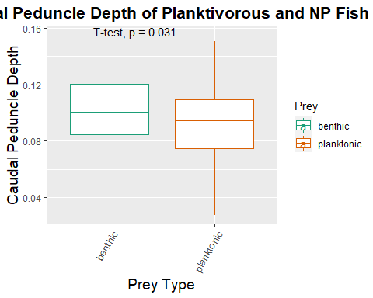

reef_fish%>%  
 ggplot(aes(x=Family,y=Caudal_peduncle_depth,color=Prey))+  
 geom_boxplot()+  
 scale_color_brewer(palette = "Dark2")+  
 theme(legend.position = "right",  
 axis.text.x = element_text(angle = 60, hjust=1,size = 10),axis.title = element_text(size = 14),plot.title = element_text(size = 16,face = "bold",hjust = .5))+  
 labs(title = "Caudal Peduncle Depth of Planktivorous and NP Fish by Family",x="Prey Type",y="Caudal Peduncle Depth")

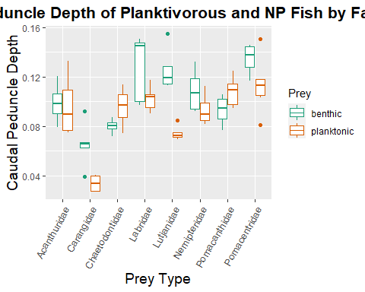

reef_fish%>%  
 ggplot(aes(x=Prey,y=Fineness_ratio,color=Prey))+  
 geom_boxplot()+  
 scale_color_brewer(palette = "Dark2")+  
 theme(legend.position = "right",  
 axis.text.x = element_text(angle = 60, hjust=1,size = 10),axis.title = element_text(size = 14),plot.title = element_text(size = 16,face = "bold",hjust = .5))+  
 labs(title = "Fineness Ratio of Planktivorous and NP Fish",x="Prey Type",y="Fineness Ratio")+stat_compare_means(method = "t.test")

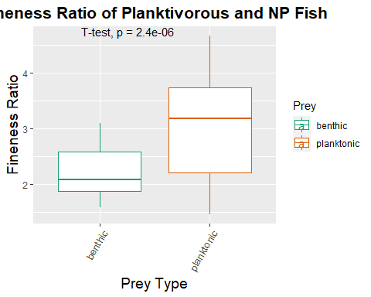

reef_fish%>%  
 ggplot(aes(x=Family,y=Fineness_ratio,color=Prey))+  
 geom_boxplot()+  
 scale_color_brewer(palette = "Dark2")+  
 theme(legend.position = "right",  
 axis.text.x = element_text(angle = 60, hjust=1,size = 10),axis.title = element_text(size = 14),plot.title = element_text(size = 16,face = "bold",hjust = .5))+  
 labs(title = "Fineness Ratio of Planktivorous and NP Fish by Family",x="Prey Type",y="Caudal Peduncle Depth")+  
 theme(axis.text.x = element_text(angle = 60, hjust=1))

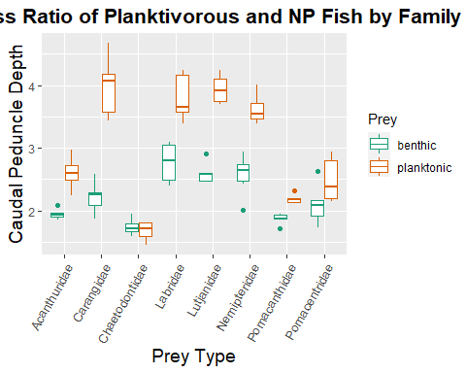

reef_fish%>%  
 ggplot(aes(x=Prey,y=Body_depth,color=Prey))+  
 geom_boxplot()+  
 scale_color_brewer(palette = "Dark2")+  
 theme(legend.position = "right",  
 axis.text.x = element_text(angle = 60, hjust=1,size = 10),axis.title = element_text(size = 14),plot.title = element_text(size = 16,face = "bold",hjust = .5))+  
 labs(title = "Body Depth of Planktivorous and NP Fish",x="Prey Type",y="Body Depth")+stat_compare_means(method = "t.test")

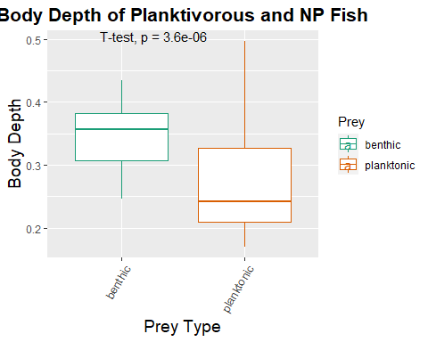

reef_fish%>%  
 ggplot(aes(x=Family,y=Body_depth,color=Prey))+  
 geom_boxplot()+  
 scale_color_brewer(palette = "Dark2")+  
 theme(legend.position = "right",  
 axis.text.x = element_text(angle = 60, hjust=1,size = 10),axis.title = element_text(size = 14),plot.title = element_text(size = 16,face = "bold",hjust = .5))+  
 labs(title = "Body Depth of Planktivorous and NP Fish by Family",x="Prey Type",y="Body Depth")

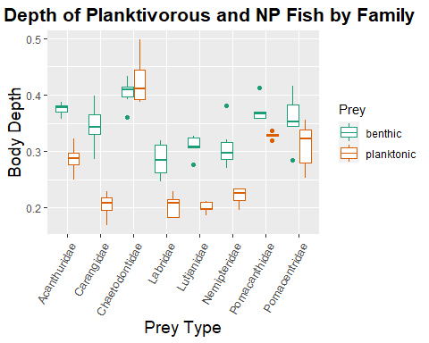

P<-reef_fish%>%  
 ggplot(aes(x=Prey,y=Body_length,color=Prey))+  
 geom_boxplot()+  
 scale_color_brewer(palette = "Dark2")+  
 theme(legend.position = "right",  
 axis.text.x = element_text(angle = 60, hjust=1,size = 10),axis.title = element_text(size = 14),plot.title = element_text(size = 16,face = "bold",hjust = .5))+  
 labs(title = "Body Length of Planktivorous and NP Fish",x="Prey Type",y="Body Length")  
P+stat_compare_means(method = "t.test")

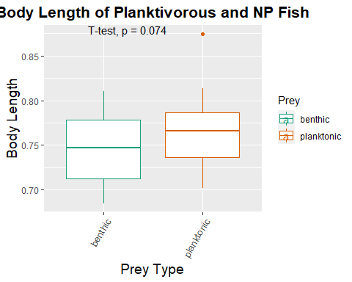

reef_fish%>%  
 ggplot(aes(x=Family,y=Body_length,color=Prey))+  
 geom_boxplot()+  
 scale_color_brewer(palette = "Dark2")+  
 theme(legend.position = "right",  
 axis.text.x = element_text(angle = 60, hjust=1,size = 10),axis.title = element_text(size = 14),plot.title = element_text(size = 16,face = "bold",hjust = .5))+  
 labs(title = "Body Length of Planktivorous and NP Fish by Family",x="Prey Type",y="Body Length")

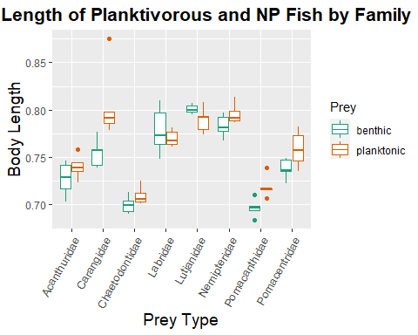

reef_fish%>%  
 ggplot(aes(x=Caudal_peduncle_depth,y=Fineness_ratio,color=Prey))+  
 geom_point(size=2.7)+  
 scale_x_continuous()+  
 scale_y_continuous()+  
 geom_smooth(method = lm,se=F)+  
 stat_regline_equation(label.y=4.9,aes(label = ..eq.label..)) +  
 stat_regline_equation(label.y=4.5,aes(label = ..rr.label..))+  
 facet_wrap(~Prey)+  
 scale_color_brewer(palette = "Dark2")+  
 theme(legend.position = "right",  
 axis.text.x = element_text(angle = 60, hjust=1,size = 10),axis.title = element_text(size = 14),plot.title = element_text(size = 16,face = "bold",hjust = .5))+  
 labs(title = "Fineness Ratio across Caudal Peduncle Depth Values",x="Caudal Peducle Depth",y="Fineness Ratio")

## `geom_smooth()` using formula 'y ~ x'

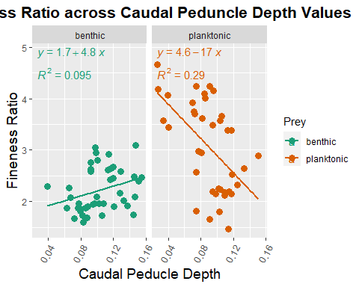

reef_fish%>%  
 ggplot(aes(x=Body_depth,y=Fineness_ratio,color=Prey))+  
 geom_point(size=2.7)+  
 scale_x_continuous()+  
 scale_y_continuous()+  
 geom_smooth(method = lm,se=F)+  
 stat_regline_equation(label.y=1.5,aes(label = ..eq.label..)) +  
 stat_regline_equation(label.y=1,aes(label = ..rr.label..))+  
 facet_wrap(~Prey)+  
 scale_color_brewer(palette = "Dark2")+  
 theme(legend.position = "right",  
 axis.text.x = element_text(angle = 60, hjust=1,size = 10),axis.title = element_text(size = 14),plot.title = element_text(size = 16,face = "bold",hjust = .5))+  
 labs(title = "Contribution of Body Depth to Different Fineness Ratios",x="Body Depth",y="Fineness Ratio")

## `geom_smooth()` using formula 'y ~ x'

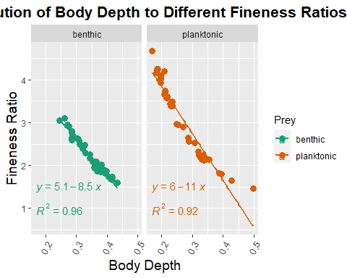

reef_fish%>%  
 ggplot(aes(x=Body_length,y=Fineness_ratio,color=Prey))+  
 geom_point(size=2.7)+  
 scale_x_continuous()+  
 scale_y_continuous()+  
 geom_smooth(method = lm,se=F)+  
 stat_regline_equation(label.y=4.5,aes(label = ..eq.label..)) +  
 stat_regline_equation(label.y=4,aes(label = ..rr.label..))+  
 facet_wrap(~Prey)+  
 scale_color_brewer(palette = "Dark2")+  
 theme(legend.position = "right",  
 axis.text.x = element_text(angle = 60, hjust=1,size = 10),axis.title = element_text(size = 14),plot.title = element_text(size = 16,face = "bold",hjust = .5))+  
 labs(title = "Contribution of Body Length to Different Fineness Ratios",x="Body Length",y="Fineness Ratio")

## `geom_smooth()` using formula 'y ~ x'

